|  |  |  |
| --- | --- | --- |
| **ر**  **ردیف دفتر ثبت** |  | **زهره مثنا**  **Official English Translator to the Judiciary**  **License No. 1387**  **Zohre Mosana**  **To verify the authenticity of the translation, please scan the QR Code** |

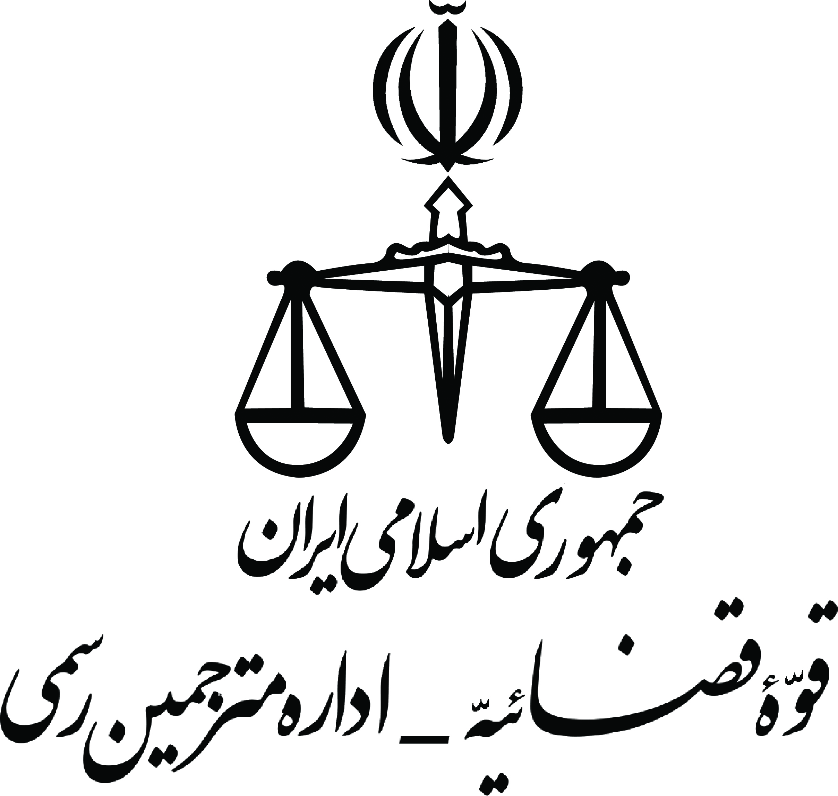

*Official translation from Persian*

Logo

**Khaneh Sabz Bahram Services**

**(Reg NO.: 523411)**

Ref. No.: 0030154

Date: 21.09.2022

Attachment: N/A

*This is hereby to certify that:*

**Mrs. Solmaz Nojavanboshroyeh,** holder of the national ID number: 0069167761 and birth Certificate number: 7454, issued in Tehran, has been elected as the shareholder of *Khaneh Sabz Bahram Services* (registry number: 523411) and a member of the board of directors on March 25, 2020.

Subject of this company includes cleaning up houses, private and public institutes, painting, remodeling and beautifying buildings and their surroundings, renovating green spaces, as well as providing human resources for companies and houses.

The above-mentioned has 1/3 of the total share portions of the company and earns 33% of its overall net benefit, equal to an average annual income of 6,400,000,000 rials.

During an official sitting on September 7, 2022, the board of directors have decided to dispatch the above-mentioned to Canada to study International Business in order to promote the management system in this company with her normal annual earnings as her mission payment.

*[Signed and Sealed]*

*Khaneh Sabz Bahram Services*

*Head of the board of directors - Bahram Rassi*

True translation from Persian is certified. Tehran – May 29, 2023

**نام صاحب سند: سولماز نوجوان بشرویه – هزینه ترجمه و خدمات دفتری: 705000 ریال بابت ترجمه نامه اشتغال به کار**

**آدرس: سعادت آباد، بین سپیدار و سرو ، پلاک 67، طبقه سوم، واحد 2**

Address: Apt No. 2, 3rd floor, No.67, Between Sarv and Sepidar st, Saadat Abad, Tehran, Iran

email: [z.mosanna@yahoo.com](mailto:z.mosanna@yahoo.com) Mobile : (+98)9125462247 Tel : (+98)2122465527